# Worksheet – 24350 (v2) Identify, select, maintain, and use portable power tools for BCATS projects

|  |
| --- |
| **Student name:** |

1. Answer the following questions for the portable power tools in the picture.

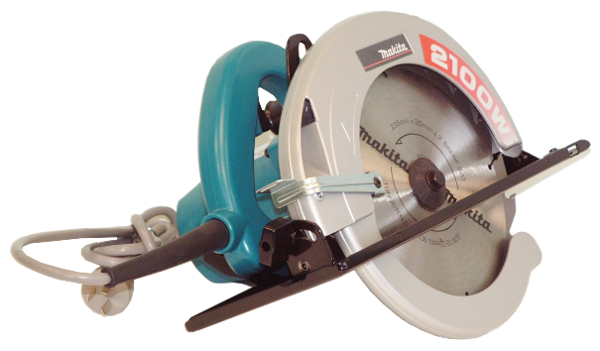

(a) What is it called, and what is it used for?

|  |
| --- |
|  |

What are **FOUR** safety precautions to be taken before and while using it?

|  |
| --- |
|  |

What PPE should you wear when using it?

|  |
| --- |
|  |

What regular maintenance and care does the tool need?

|  |
| --- |
|  |

(c) What is it called, and what is it used for?

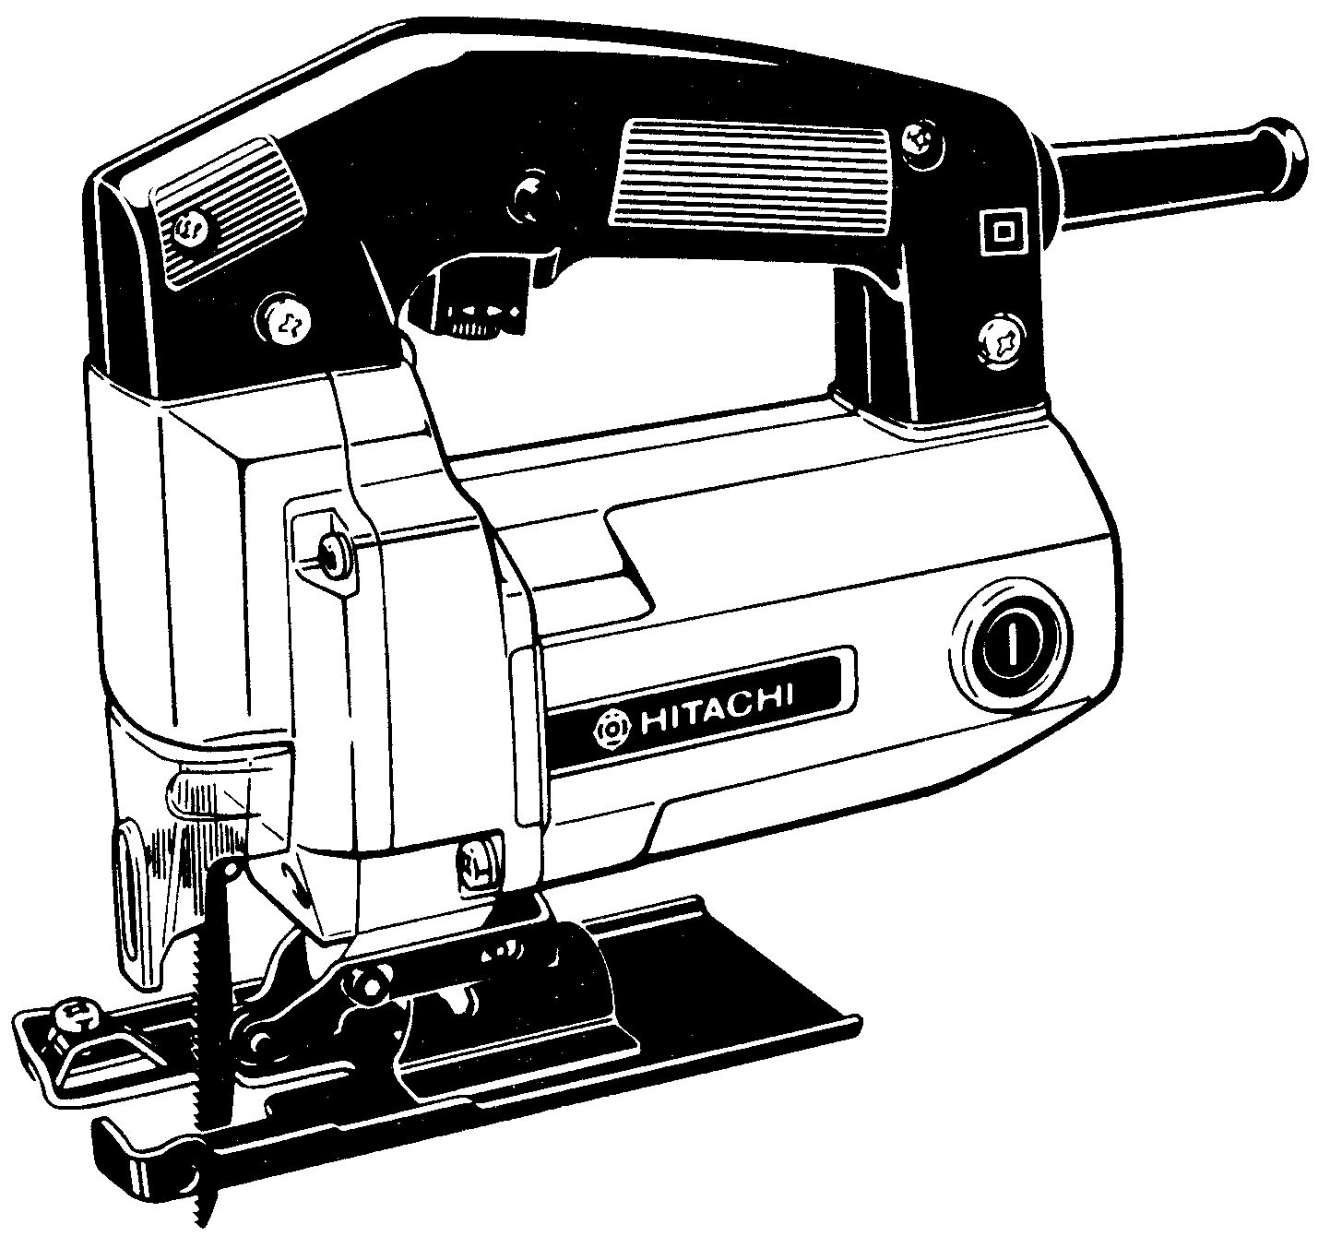

|  |
| --- |
|  |

What are **FOUR** safety precautions to be taken before and while using it?

|  |
| --- |
|  |

What PPE should you wear when using it?

|  |
| --- |
|  |

What regular maintenance and care does the tool need?

|  |
| --- |
|  |

(c) What is it called, and what is it used for?

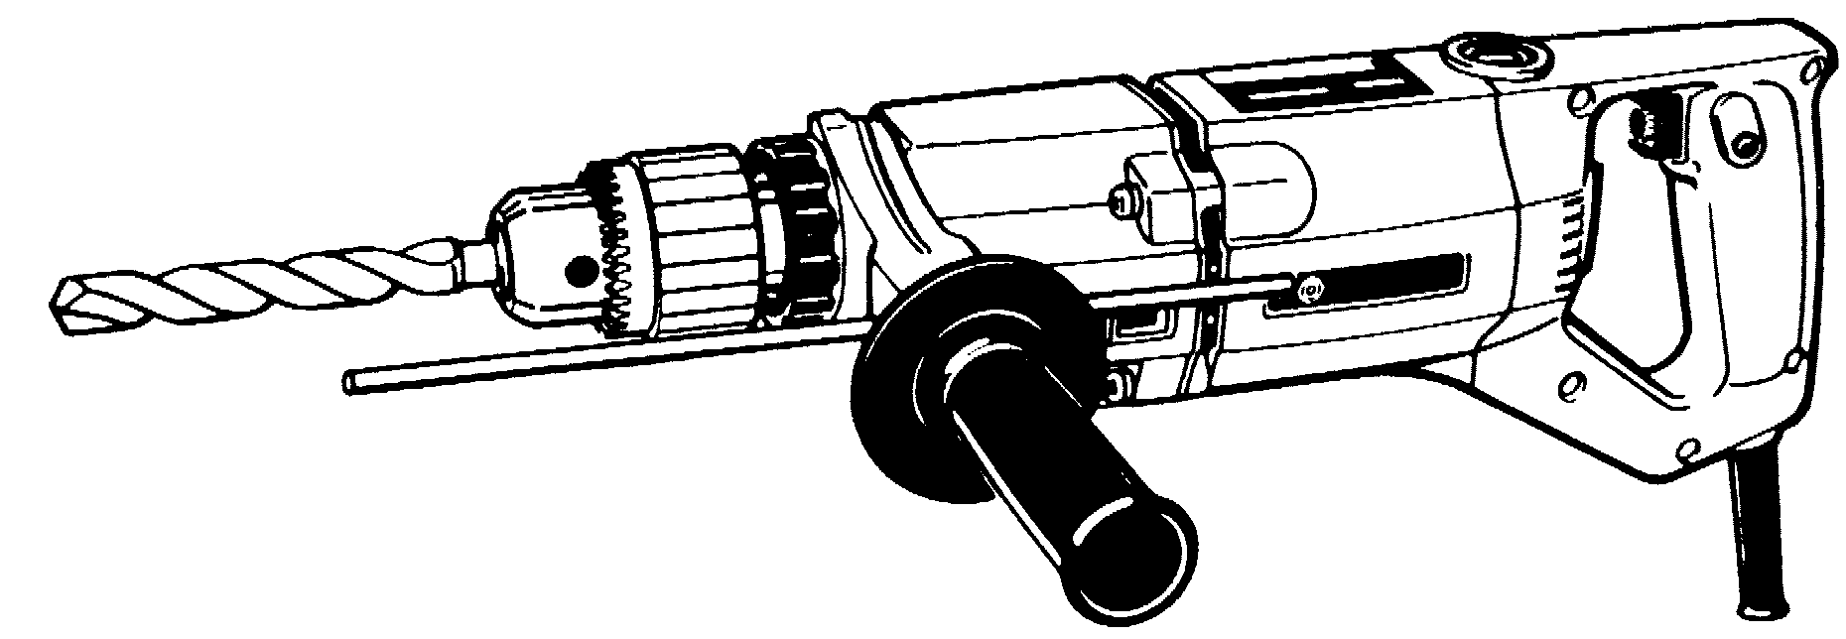

|  |
| --- |
|  |

What are **FOUR** safety precautions to be taken before and while using it?

|  |
| --- |
|  |

What PPE should you wear when using it?

|  |
| --- |
|  |

What regular maintenance and care does the tool need?

|  |
| --- |
|  |

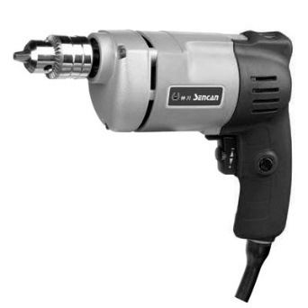

(d) What is it called, and what is it used for?

|  |
| --- |
|  |

What are **FOUR** safety precautions to be taken before and while using it?

|  |
| --- |
|  |

What PPE should you wear when using it?

|  |
| --- |
|  |

What regular maintenance and care does the tool need?

|  |
| --- |
|  |

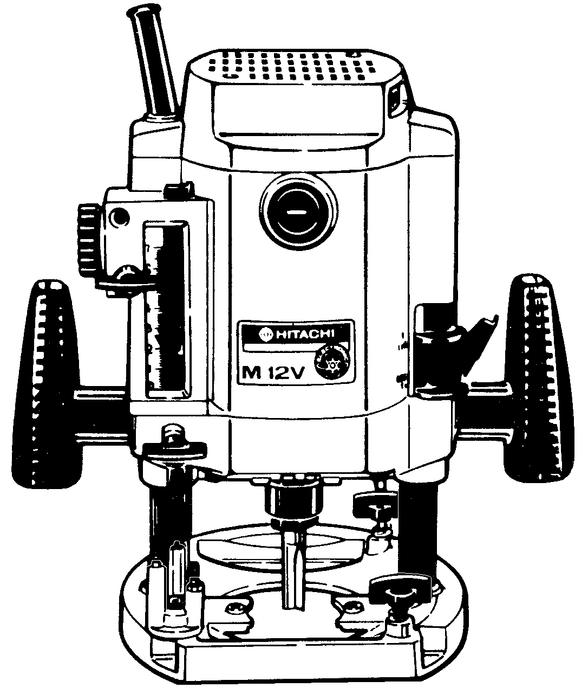(e) What is it called, and what is it used for?

|  |
| --- |
|  |

What are **FOUR** safety precautions to be taken before and while using it?

|  |
| --- |
|  |

What PPE should you wear when using it?

|  |
| --- |
|  |

What regular maintenance and care does the tool need?

|  |
| --- |
|  |

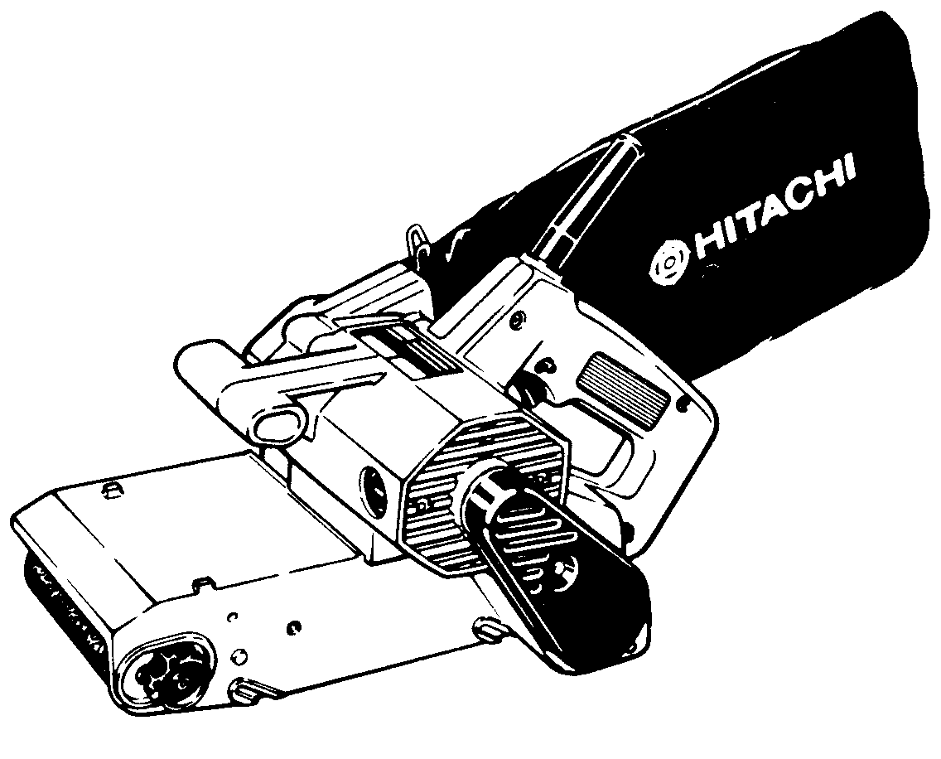(f) What is it called, and what is it used for?

|  |
| --- |
|  |

What are **FOUR** safety precautions to be taken before and while using it?

|  |
| --- |
|  |

What PPE should you wear when using it?

|  |
| --- |
|  |

What regular maintenance and care does the tool need?

|  |
| --- |
|  |



(g) What is it called, and what is it used for?

|  |
| --- |
|  |

What are **FOUR** safety precautions to be taken before and while using it?

|  |
| --- |
|  |

What PPE should you wear when using it?

|  |
| --- |
|  |

What regular maintenance and care does the tool need?

|  |
| --- |
|  |

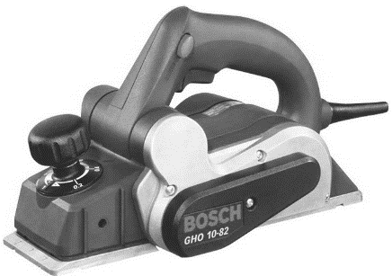

(h) What is it called, and what is it used for?

|  |
| --- |
|  |

What are **FOUR** safety precautions to be taken before and while using it?

|  |
| --- |
|  |

What PPE should you wear when using it?

|  |
| --- |
|  |

What regular maintenance and care does the tool need?

|  |
| --- |
|  |

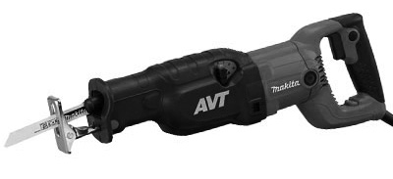

(i) What is it called, and what is it used for?

|  |
| --- |
|  |

What are **FOUR** safety precautions to be taken before and while using it?

|  |
| --- |
|  |

What PPE should you wear when using it?

|  |
| --- |
|  |

What regular maintenance and care does the tool need?

|  |
| --- |
|  |

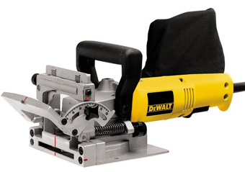(j) What is it called, and what is it used for?

|  |
| --- |
|  |

What are **FOUR** safety precautions to be taken before and while using it?

|  |
| --- |
|  |

What PPE should you wear when using it?

|  |
| --- |
|  |

What regular maintenance and care does the tool need?

|  |
| --- |
|  |

1. What are the possible consequences of failing to disconnect a power tool from the power source before adjusting the tool?

|  |
| --- |
|  |

1. The power lead that you are about to use has a kink inside the outer case. What does this indicate and is the lead safe to use?

|  |
| --- |
|  |

1. You have been instructed to finish a solid timber bench top in preparation for the spraying of its finish coat. The selection of power tools that you have to choose from are listed below:

**Orbital sander Belt sander In-line sander**

**Disc sander Palm sander**

Which of these sanders will do the job in the least amount of time?

|  |
| --- |
|  |

Which will give you the best finish?

|  |
| --- |
|  |

Which of the above sanders would be least suited to the task? Explain why you would not use it for finishing work:

|  |
| --- |
|  |

1. You are preparing a router for use. List **THREE** safety checks that you should carry out before plugging in the machine.

|  |
| --- |
| 1  2  3 |

1. You are ripping a length of timber down to width using the skill saw. What can you do to help prevent the timber jamming on the blade?

|  |
| --- |
|  |

1. Describe the potential consequences of machining work that is not securely attached to the bench.

|  |
| --- |
|  |

1. If your power tool starts to smoke, what should you do?

|  |
| --- |
|  |

1. You have just finished sanding the top of a table with the orbital sander and the surface shows visible semicircular scratch marks. What could have caused these scratch marks?

|  |
| --- |
|  |

1. How and where should power tools be stored?

|  |
| --- |
|  |