# Worksheet - 24354 (v2) Demonstrate knowledge of and apply safe working practices in a BCATS environment

|  |
| --- |
| **Student name:** |

1. What is the main purpose of the Health and Safety at Work Act?

|  |
| --- |
|  |

1. What is the main purpose of the Health and Safety at Work Regulations?

|  |
| --- |
|  |

1. What are your responsibilities as a “worker” under the Health and Safety at Work Act?

|  |
| --- |
|  |

1. What is a person conducting a business or undertaking’s (PCBUs) main responsibility under the Health and Safety at Work Act?

|  |
| --- |
|  |

1. Complete the following chart for your BCATS environment:

|  |  |  |
| --- | --- | --- |
|  | **A. Potential hazard**  (Complete all this column) | **B. Possible control measure**  (Complete at least 4 in this column) |
| Electrical |  |  |
| Chemical |  |  |
| Fire |  |  |
| Fumes |  |  |
| Gas |  |  |
| Compressed air |  |  |
| Noise |  |  |
| Material |  |  |
| Falling |  |  |
| Lifting |  |  |

1. Identify the meanings of the following signs:

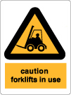

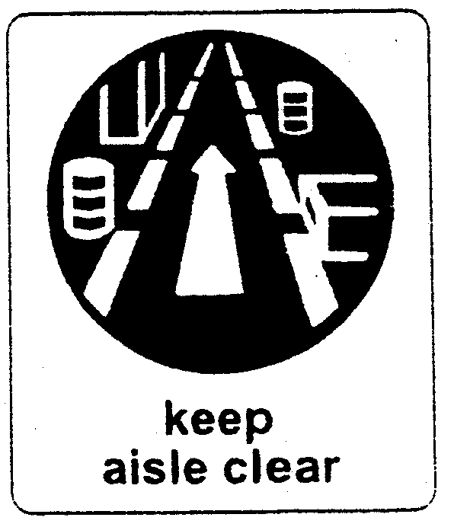

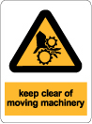

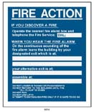

1. Identify hazards associated with each of the following safety issues.

Loose clothing:

|  |
| --- |
|  |

Long hair:

|  |
| --- |
|  |

Non-safety footwear:

|  |
| --- |
|  |

Wearing jewellery:

|  |
| --- |
|  |

Poor lifting technique:

|  |
| --- |
|  |

Handling or moving of heavy objects:

|  |
| --- |
|  |

Occupational overuse syndrome:

|  |
| --- |
|  |

Heights:

|  |
| --- |
|  |

Not enough training:

|  |
| --- |
|  |

1. Describe the steps you should follow in your workplace in the event of:

a) Fire

|  |
| --- |
|  |

b) Earthquake

|  |
| --- |
|  |

c) Accident:

|  |
| --- |
|  |

d) Chemical spill:

|  |
| --- |
|  |