# Activity 2 – 24361 (v2) Apply mathematical processes to BCATS projects

|  |
| --- |
| **Student name:** |

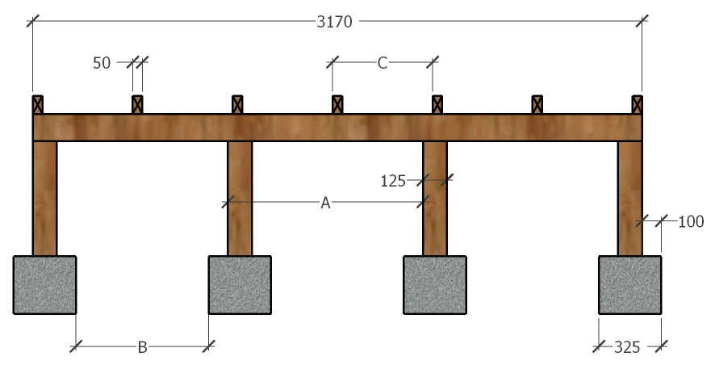

1. **a)** A deck needs to be constructed. (See sketch above.) The length of the deck is 3.170m. The foundation piles are 125 x 125 H4 radiata pine mounted in 325 x 325 concrete footings. Four are to be evenly spaced along its length. Calculate the under over measurement spacings (Distance A on the sketch).

|  |
| --- |
|  |

**b)** You are preparing to dig out the footings. They are 325 x 325mm. Calculate the distance between the holes (Distance B on the sketch).

|  |
| --- |
|  |

**c)** Seven joists need to be equally spaced along the bearer. Calculate the distance between centres for the joists to be positioned (Distance C on the sketch). (Over and under measurements are the same as centre to centre)

|  |
| --- |
|  |

1. Complete the table below by converting the dimensions in the left column into millimetres and metres, millimetres and centimetres, or centimetres and metres.

|  |  |  |  |  |
| --- | --- | --- | --- | --- |
|  | Number | millimetres | centimetres | metres |
|  | Example 5cm | 50 | - | .05 |
| a. | 75 mm |  |  |  |
| b. | 25 cm |  |  |  |
| c. | 1.3 m |  |  |  |
| d. | 126 cm |  |  |  |
| e. | 5 mm |  |  |  |
| f. | 3800 mm |  |  |  |
| g. | 1390mm |  |  |  |
| h. | .05 m |  |  |  |
| i. | .8 m |  |  |  |
| j. | .001 m |  |  |  |
| k. | 109500 mm |  |  |  |
| l. | 324 cm |  |  |  |
| m. | .4 cm |  |  |  |
| n. | 5.600m |  |  |  |

1. A path measures 750mm wide x 75mm thick x 5.5m long. Express all of the dimensions as metres.

x x

1. Select the most suitable measuring tool and record the following dimensions in both millimetres and metres.

|  |  |  |
| --- | --- | --- |
|  | **Millimetres** | **Metres** |
| **Height of a door** |  |  |
| **Thickness of a door** |  |  |
| **Length of a wall** |  |  |
| **Height of a desk** |  |  |

1. The length of a fence is 24 metres. The posts are to be spaced 2 metres apart. How many posts do you need to order?

|  |
| --- |
|  |

1. Using the series of individual measurements from a building plan detailed below, calculate the dimension of the running and the overall measurements.

A

D

G

4800

1500

100

2660

3615

200

Individual

Running

Overall

B

C

E

F

190

H

|  |  |
| --- | --- |
| A |  |
| B |  |
| C |  |
| D |  |
| E |  |
| F |  |
| G |  |
| H |  |